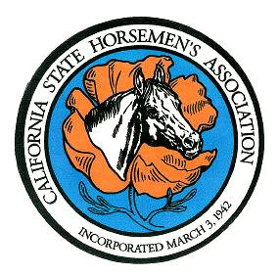

**CALIFORNIA STATE HORSEMEN’S ASSOCIATION, INCORPORATED**

**81st ANNUAL CONVENTION – November 10-12, 2023**

Hotel Mission De’ Oro- Santa Nella, CA

**REGISTRATION FORM**

**INDIVIDUALS ONLY**

* **DEADLINE for Pre-registration – November 1, 2023 POSTMARK DATE**
* ONE Person per Registration Form
* IF you are carrying a CLUB VOTE, The **CLUB MUST ALSO REGISTER** on the CLUB Registration Form
* PLEASE PRINT ALL INFORMATION

Voting Member: (**check one)** Life _______ Senior ________ Family _______

CSHA Membership # _______________ REGION # ________

NAME: __________________________________________________________________

ADDRESS ________________________________________________________PHONE _________________

State Officer / Committee Chairman ____________________ Region Chair ____________________

Guest Name / Non-Voting Club Member ________________________________ Club Name: ___________________

Direct Member (VOTING) Registration #_____ X **$20.00** After Nov 1st $25 **$________**

Non-Voting Member, Guest, Junior #_______X **$10.00** After Nov 1st $15 **$_________**

DAY ATTENDANCE: **Friday/ only committee meetings**

**Friday /Saturday - Meetings/ Council Registration**

***************************************************************************************

**81st Annual Reception & Installation of Officers**: **Saturday Nov. 11th**

Hors’d oruves and no-host bar/ beverages; 7pm; cocktail / business attire

***Limited tickets at the door $35 /$20***

**Adult** #___ X **$30.00 =________**

**Youth** # ___X **$15.00= ________**

Checks or money orders payable to: CSHA Convention

Mail to: CSHA Office

1330 W. Robinhood Drive -Suite D

Stockton, CA 95207

**Postmark by: November 1st**

*You may use one check to pay for multiple items:* **Total Enclosed: $_________**