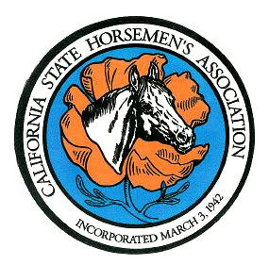

**CALIFORNIA STATE HORSEMEN’S ASSOCIATION, INCORPORATED**

**81st ANNUAL CONVENTION – November 10-12, 2023**

**Hotel Mission De’ Oro- Santa Nella, CA**

**CONVENTION REGISTRATION FORM – CLUBS ONLY**

* **DEADLINE for Pre-Registration is November 1, 2023; Postmark Date**
* **ONE Club per Registration Form**
* **One person representing the Club will vote**
* **Please PRINT all information**
* **Club Representatives must be an Adult Member in good standing listed on the Club’s roster as of September 1st**
* **If the club is sending more than one representative, additional fees will be required – see below**

**CLUB NAME: ________________________________________________________Region # _______**

**Mailing Address:_____________________________________________________________________**

**Council of Members (may name two people)**

**Representative: __________________________________________________**

**Alternate Representative: __________________________________________________**

**Registrations Fees**

**One (1) Representative $ 20.00 x #____ = $ ______**

After November 1st, 2023 $ 25.00 x # ____= $ ______

**Additional Representative $ 15.00 x # ____ = $ ______**

After November 1st. 2023 $ 20.00 x # ____ = $ ______

**Total $ _______**

**CLUB CREDENTIALS FORM Must be attached, Signed by the Club President or Secretary.**

***Club Member(s) attending Friday Committee Meetings Only***

**\*\*\*\*\*\*\*\*\*\*\*\*\*\*\*\*\*\*\*\*\*\*\*\*\*\*\*\*\*\*\*\*\*\*\*\*\*\*\*\*\*\*\*\*\*\*\*\*\*\*\*\*\*\*\*\*\*\*\*\*\*\*\*\*\*\*\*\*\*\*\*\*\*\*\*\*\*\*\*\*\*\*\*\*\*\*\*\*\***

**81th Annual Reception & Installation of Officers**:

**Saturday Nov. 11th**

Hors’d oruves and no-host bar/ beverages; 7pm; cocktail / business attire

***Limited tickets at the door $35 /$20***

**Adult** #___ X **$30.00 =________**

**Youth** # ___X **$15.00= ________**

Checks or money orders payable to: CSHA Convention

Mail to: CSHA Office

1330 W. Robinhood Drive -Suite D

Stockton, CA 95207

**Postmark by: November 1st**

*You may use one check to pay for multiple items:* **Total Enclosed: $_________**